República de Cuba
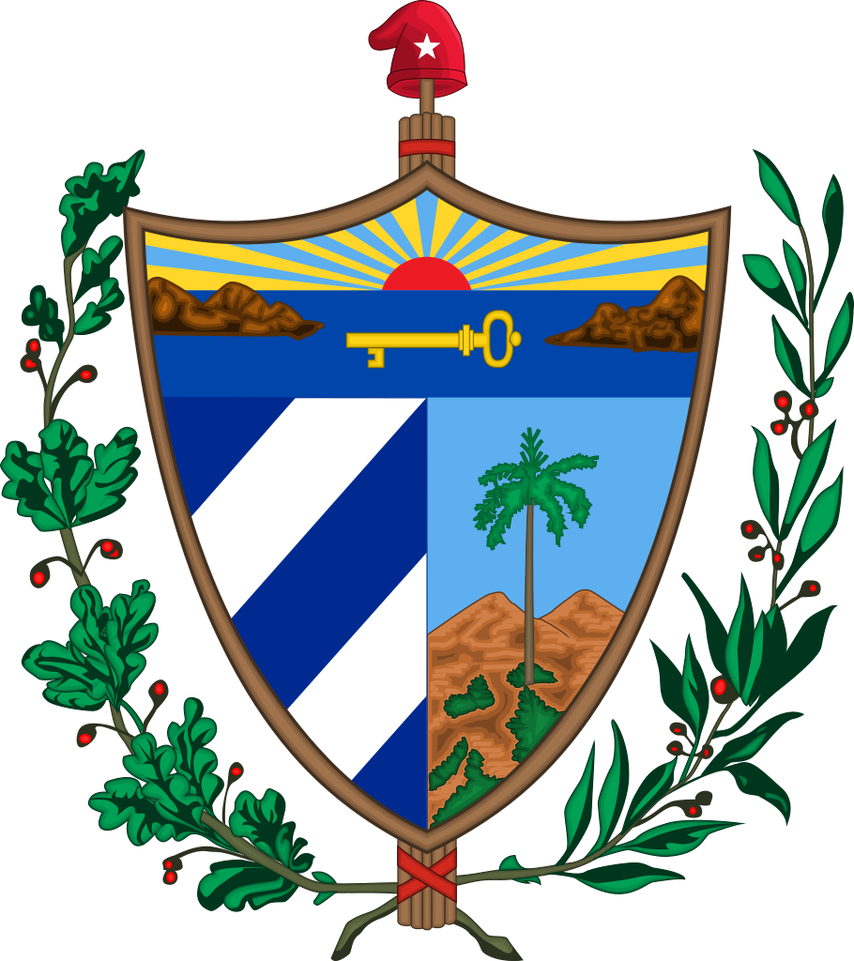
POSITION PAPER

República de Cuba
Position Paper for the 2018 ESMOAS Summit of the Americas

- GENERAL STATEMENT

Cuba is thankful to every member of the Organization of American States (OAS) for their continued efforts in strengthening the peace of the Western hemisphere and is proud to be attending as a complete represented member of the OAS. As a founding member, Cuba recognizes the purpose of this collaboration, which is to form solutions that integrate the values of integrity and concord. Maintaining the solidarity demonstrated is of utmost importance in order to meet the goals of each nation and seek a unified future for the Americas.
Cuba’s rich history of unbridled courage and honor brings the state to the annual Summit of the Americas. For the reason that Cuba was granted an invitation to reinstate its rights as a member state, Cuba attends with respectful intent. However, Cuba has not officially returned to the OAS as a full member and will not be doing so in the foreseeable future. This is to preserve the virtue of Cuba and the ideals of the nation.
The Republic of Cuba is a nation born of a great struggle for the common good and has proven its sacrifices worthy through the government’s loyalty to the independence and self-support that Cuba has always strived for. The people of Cuba live in a country where they can be provided top quality health care and education because of the reforms the Cuban people felt were important to them. Cuba has also created valuable assets for itself through the fight for a revolution against the working citizen’s oppression. Because of its contrary views to the majority of the Western hemisphere, Cuba has long been ostracized. Cuba, despite all odds, will always overcome the obstacles it faces and wishes to share this determination with the rest of the nations.

República de Cuba
Position Paper, Page Two

II. PARTICULAR STATEMENTS

A. Committee: General Committee (GC)

Topic A: Addressing the Rights of Migrants, Refugees, and Asylum Seekers

The delegation of Cuba firmly believes in the rights of migrants, refugees, and asylum seekers throughout the Western hemisphere. Cuba has followed the image of other United Nations member states in facilitating the immigration of many groups of people. Cuba has held open arms to other nations when they arrive in Cuba to escape poverty and inadequate care by the government. The country holds great pride in being a land of opportunity and equality, and that allows immigrants to feel welcomed when beginning a new chapter.
While Cuban citizenship is restricted to native-born people, Cuba has recently lifted its heavy laws in obtaining this citizenship and has opened its residents to include direct Cubans born in other countries and if they are married to a Cuban or permanent resident. This is because of the policies that Cuba has pushed in order to align with the ideals that Cubans share. Cuban citizens should take pride in their heritage and nation, and therefore while Cuba is open, it also would like to remain reserved in selectivity of Cuban citizens by still imposing some restriction so that they can preserve the culture of the nation.

B. Committee: Executive Secretariat for Integral Development (SEDI)

Topic A: Combating Climate Change

The Delegation of Cuba has seen a rising effect on the damage caused by hurricanes throughout the years. Cuba has committed to the principles and objectives established in the charter of the Organization of American States in order to strengthen the peace and security of the country and to prevent possible causes of difficulties that may arise due to heavy rain and winds during hurricane season¹. Nonetheless, The Delegation is concerned with the health of Cuban citizens and the expenses for relocating and repairing the damage left behind by the elements. The cabinet of Cuba is perturbed by the thought of repairing this years’ damage while preparing for the following season. The Delegation is asking the Organization of American States to comply with the charter and to aid Cuba to seek the solution of economic problems that may arise as a result of climate change¹. Cuba has taken the initiative to prevent as much damage as possible with a one-hundred-year plan named Tarea Vida, or “Project Life”². The plan mentioned above bans construction of new homes in the coasts that have been damaged constantly by hurricanes². Tarea Vida is also planning to restore mangroves throughout the coast in order to protect the coast from the elements as a source of first defense for the communities located on and around the coast².

C. Committee: Secretariat for Multidimensional Security (SMS)

Topic A: Combating Human Trafficking in the Hemisphere

The delegation of Cuba strongly believes that the combat of human trafficking is essential to the hemispheric scheme of personal assurance and believes in the support of human trafficking victims. Under Chapter I, Article 2 section A of the OAS Charter, the organization of American states’ purpose is to “strengthen the peace and security of the continent”, and perhaps the most fundamental assurance of peace and security is that of a personal nature³. Although Cuba has no immediate or severe issues in human trafficking, Cuba prides itself on this accomplishment and will only like to see other countries accomplish the same feat.
A major method utilized by the government of Cuba in order to achieve such honorable standards of personal protection is by primarily protecting the youth of the nation; specifically, Cuba has discontinued the admission of minors in zones that are known to be high-risk of human trafficking such as nightclubs and other areas in which children were allowed to attend⁴. It has often been seen in other countries that such areas are vulnerable to potential victims of human trafficking and can be especially detrimental to the safety of children and adolescents. Although human trafficking statistics of Cuba have not shown a decrease on that particular crime due to the country having little to none illegal activities, the delegation believes that such policies can be effective methods of deterrence for human trafficking in other countries. Therefore, in the name of multidimensional security and the safety of citizens in the Western hemisphere, the delegation of Cuba shall be advocating for other member states to adopt the country’s exemplary policies regarding this vital issue

Topic B: Improvement of Food Security & Sustainable Forestry and Fisheries

The concern of food security is of great priority to the OAS. Sustainable forestry and fisheries in Cuba is of utmost importance and parallels the mission of the OAS. Cuba believes that the assurance of food security can be attained by keeping sustainable forests and fisheries. As a country of coastal richness, Cuba is aware that it is surrounded by a vital resource that can maintain the country. As a result, Cuba is very interested in preserving its forests and fisheries.
A country’s resources are an imperative part of the development of society within the country. Therefore, each member of the OAS should be concerned with preserving its ecological treasures. For coastal communities, it is of concern the declining resources available along the coast⁵.As a result, Cuba has made an effort to replenish marine life in a four-year project named SOS Pesca.
Maintaining healthy fisheries and forestry should be a world effort and the OAS is correct in maintaining its support towards this effort. Through the collaboration of members of the OAS, an effort for sea turtle conservation was made⁶. It is clear that members of the OAS are not only interested in maintaining a healthy environment for food security, but also to protect wildlife. As research shows, collaborating countries have a better opportunity to make effective strides towards healthier ecosystems for the benefit of the member states of the OAS and for humanity as a whole.
The deterioration of the Zaza River has called for the research of effective methods to protect natural resources across Cuba⁷. The universities of Malaga and Sancti Spiritus joined efforts to replenish the Zaza River. It is through collaborative efforts of academic interests that the nation of Cuba is able to support its political efforts. Further research on the subject will not only help Cuba and surrounding states on ecological matters but will also develop a higher interest in academic efforts among members of the OAS.
The Delegation of Cuba, therefore, provides strong support for research and initiatives that protect marine life and ecosystems. Through the compilation of research and gained knowledge the delegation of Cuba as well as the member states of the OAS should enact legislative procedures to protect its vital resources and as a result ensure food security. The suggested process will not only provide Cuba with the protection of its vital resources but will spark interest among the Cuban people and will develop an academic interest in the country as a whole.

WORKS CITED

- Oas.org. (2018). OAS:: SLA:: Department of International Law (DIL):: Inter-American Treaties.
- [online] Available at: http://www.oas.org/en/sla/dil/inter_american_treaties_A-41_charter_OAS.asp [Accessed 20 Oct. 2018].2. Stone, Richard. "Cuba Embarks on a 100-year Plan to Protect Itself from Climate Change." Science, 2018. doi:10.1126/science.aas9688.
- OAS Charter
- "Trafficking in Persons Report." U.S. Department of State. 2010. https://www.state.gov/j/tip/rls/tiprpt/2010/142759.htm.
- http://www.medigraphic.com/pdfs/medicreview/mrw-2018/mrw182m.pdf The SOS Pesca Project: A Multinational and Intersectoral Collaboration for Sustainable Fisheries, Marine Conservation and Improved Quality of Life in Coastal Communities Miller, Valerie, et al. "The SOS Pesca Project: A Multinational and Intersectoral Collaboration for Sustainable Fisheries, Marine Conservation and Improved Quality of Life in Coastal Communities." Lessons in International Cooperation 20, no. 2 (April 2017): 65-70. MEDICC Review, Medic Graphic (accessed October 16, 2018).
- https://www.sciencedirect.com/science/article/pii/S0308597X16303062 Fisheries learning exchanges and sea turtle conservation: An effort between Mexico, Cuba and the U.S. to engage Cuban coastal communities in non-consumptive alternative behaviors. Bretos, Fernando, et al. “Fisheries learning exchanges and sea turtle conservation: An effort between Mexico, Cuba, and the U.S. to engage Cuban coastal communities in non-consumptive alternative behaviors.” Marine Policy 77 (March 2017): 227-230. Elsevier. Science Direct. (accessed October 16, 2018)
- https://riuma.uma.es/xmlui/handle/10630/14093 Preliminary proposal of environmental and conservation flows of the ecosystem of the Zaza river downstream of Zaza dam (Cuba). Garcia, Diana; Jimenez-Gavilan, Pablo. "Preliminary proposal of environmental and conservation flows of the ecosystem of the Zaza river downstream of Zaza dam (Cuba)." (July 2017): Repositorio Institucional de la Universidad de Malaga, Universidad de Malaga (accessed October 16, 2018).

