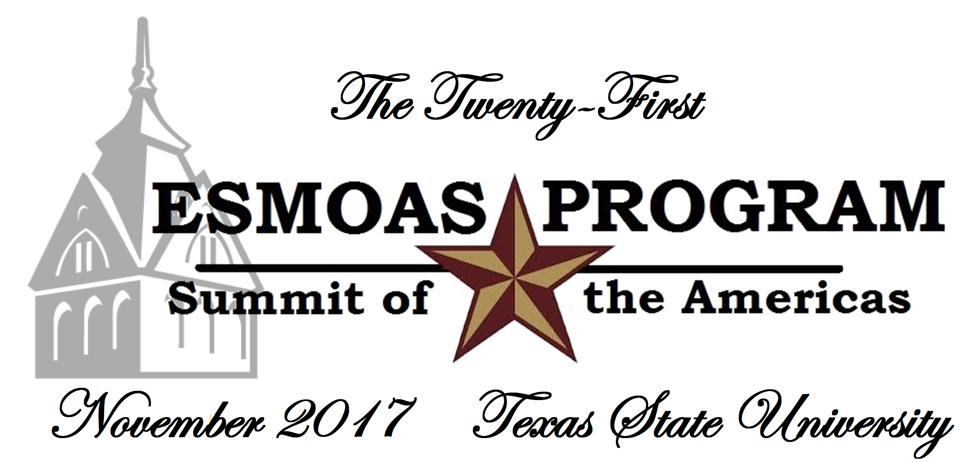
2017 Eugene Scassa Mock OAS
Student Steering Committee
Nomination Form

*Please complete and return this form via in person to the ESMOAS Program Director or Secretary General before the closing of the 2017 ESMOAS conference.

Name of Student: ________________________________
Student’s Phone: ____________________

Student’s Email: _________________________________________________

School: _________________________________________________

ELIGIBILITY: Student Steering Committee Representatives must be active team members and returning for the 2018 ESMOAS conference, provided their team registers. By agreeing to serve on the committee, the student is committing to attend the 2018 conference, unless his/her school does not register. Student Steering Committee Representatives may not be officers for the 2018 ESMOAS, nor can they be currently serving as an officer of the 2017 ESMOAS (e.g. President, Secretary-General, Parliamentarian).

DUTIES: The Student Steering Committee assists the Head Coordinator and Steering Committee with suggestions on rule changes and logistical changes to make the conference and competition more fair, equitable, and academically profitable for student participants. The committee will meet with the Secretary General and Parliamentarian immediately following the Closing Plenary Session of the conference in order to discuss possible changes to the next year’s model. The Secretary General will then produce a report from the SSC to present to the model Steering Committee. After the conference, committee communication will be done through email and/or a designated social media group for the committee. Student Steering Committee Representatives will be recognized at the conference awards reception at the end of their service.

______________________________________ _____________________________________
Signature of Student Nominee Signature of Head Delegate or Faculty Advisor

