THE UNITED STATES OF AMERICA
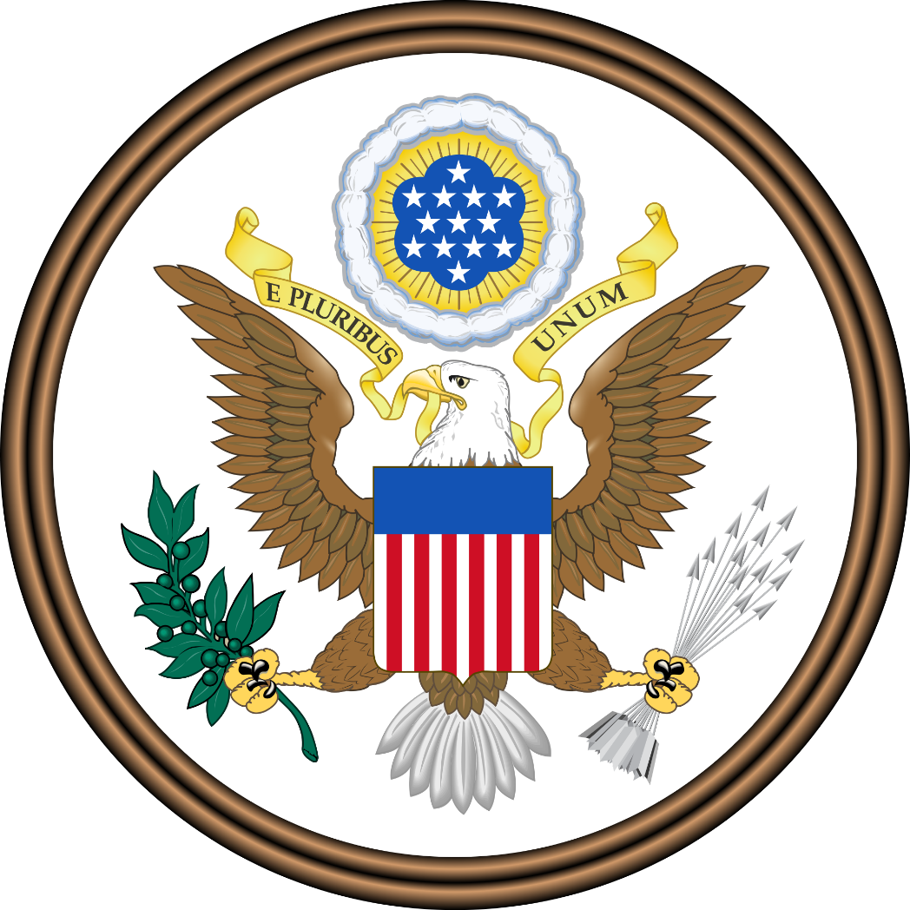
Position Paper
2018

United States of America
Position Paper for the 2018 ESMOAS Summit of the Americas

I. GENERAL STATEMENT
The United States of America is honored to attend, once again, the Summit of the Americas along with the participation of all the other member countries of the hemisphere. As a founding member and one of the main countries of the Organization of American States (OAS), the United States of America (USA) is interested in continuing to protect the principles and the values that were committed since we signed the Charter of this Organization.
Thus, the United States (US) reaffirms its compromise on strengthening peace and security in the hemisphere; to promote and consolidate representative democracies, with due respect for the principle of nonintervention; to prevent possible causes of disagreement and to ensure the peaceful settlement of disputes that may arise among the member states. We also have a duty to seek the solution of political, juridical, and economic problems that may arise among the States and to promote, through cooperative action, their economic, social, and cultural development.
Furthermore, The United States, under the presidency of Donald J. Trump, is proud to announce that, this year, the interests of the American people will be earnestly represented by this delegation. Since President Trump took office, power was handed back to the people and campaign promises have been and will continue to be accomplished.
President Trump’s priority is the safety and security of the American people (The White House, Office of the Press Secretary, 2017), which is why the Trump Administration is firmly committed to addressing threats that concern the United States, including transnational organized crime and illicit trafficking networks as well as the drivers of instability and irregular migration (Tillerson, 2017). Understanding that no member state remains unaffected by these regional security challenges and that no member state alone can fully address them, the Delegation of the United States expresses its intention and readiness to work with fellow member states in facing these shared threats.

United States of America
Position Paper, Page Two

The United States is also ready to look for the economic stability of the countries in the continent since we recognize it is cause for many of the problems that have become a crisis in the hemisphere. We remind member states that our country is always ready to become a great ally as long as we come to an agreement beneficial to all parties. Still, we would like every government in Latin America to take into account that free market and trade are matters that must be addressed bilaterally and according to particular conditions.
Attending migration, The United States is always ready to receive immigrants in a controlled and secure matter that does not represent an economic or safety risk for Americans. Convinced that a government’s first and foremost duty is with its people, the President announced that under his administration he “will focus on ending the absolutely horrific practice of human trafficking” (The White House, 2018), specifically in those countries that are going through a domestic crisis. Therefore, we call upon all members to continue working on satisfying the necessities of their nationals.
The United States are also committed to promoting and defending representative democracy. President Trump is convinced that “all people deserve a government that cares for their safety, their interests, and their wellbeing”(Trump, 2017). In light of this conviction, the United States condemns all authoritarian powers that “respect neither their own citizens, nor the sovereign rights of their countries” (Trump, 2017).
We, the American states, must also take into consideration other problems that are affecting our continent. Food security and climate change have also become a part of the American international agenda and we will address them as well. Still, we must acknowledge that every country must attend the matter as they see fit and without compromising the economic stability of the region.
The Trump administration and the United States as a whole will continue to work towards making this Western Hemisphere the land of democracy, liberty and prosperity that it deserves to be. Along with the OAS, we will be able to come up with solutions that benefit us all.
May God bless the American States.

United States of America
Position Paper, Page Three

II. PARTICULAR STATEMENTS

A. General Committee (GC)

Topic A: Addressing the Rights of Migrants, Refugees and Asylum Seekers.
Regarding Topic A, about the human rights of migrants, refugees and asylum seekers, the United States would like to state that every member must protect the rights of displaced people that run away from their countries due to humanitarian crisis and undemocratic governments. Taking, for example, the crisis in Venezuela, each country must be ready to recognize immigrants as refugees in a responsible manner, so that they are able to cover their basic needs and introduce them into its workforce.
On September 25, Vice President Mike Pence addressed a conference on regional migration at the United Nations (UN) Headquarters in New York to express our concern on what our country and others, such as Colombia, find as “arguably the worst crisis Latin America has faced” (U.S. Mission to the Organization of American States, September 25, 2018b.). During such meeting, the Vice President also announced that the United States Government would provide $48 million, additional to the previous $45 million destined to solve the humanitarian crisis and help to receive governments to protect human rights (U.S. Mission to the Organization of American States, September 25, 2018b.). This expresses the great concern our government has for the situation in the region.
In the same way, we will continue to see for the sovereignty of every democratic country in America. As President Trump stated in the UN General Assembly, “we recognize the right of every nation … to set its own immigration policy in accordance to its national interest” (U.S. Mission to the Organization of American States, September 25, 2018a.). Therefore, we will only ask neighbor countries to try and receive as many migrants, refugees and asylum seekers as responsibly possible. If recognized as such, member countries will be able to grant safety, employment, health, education and all human right stated in the resolution 2/18 made by the Inter-American Commission on Human Rights (IACHR). (IACHR, 2018)

United States of America
Position Paper, Page Four

Still, as Vice President Pence stated, “we know that providing aid to those who are suffering under the tyranny in Venezuela is not the real answer. This crisis will only keep growing as long as the Maduro regime remains in power…” (U.S. Mission to the Organization of American States, September 25, 2018b.); that is why we will continue to condemn the regime and support previous resolutions that address the political crisis. Therefore, we must continue our efforts to recognize the real origin of the dangerous situation and continue to pressure for it to change.
Let us not forget that illegal migration is also a source for other illegal actions, such as drug trafficking and human smuggling; very cruel practices that also threaten human rights of the truly needed migrants (U.S. Mission to the Organization of American States, September 25, 2018a.). That is why we still need to work towards security on the hemisphere. This is an aspect that must not be forgotten.
Finally, the United States will continue to emphasize the need for Venezuela to become a democracy again, on the urge for neighbor countries to receive as many refugees as possible and guarantee their human rights. Also, we recognize the need to make financial resources available for receiving countries to be able to satisfy the needs of the immigrants, since states are responsible for protecting human rights, democracy and liberty. We wish that for migrants, refugees and asylum seekers, and that is what the resolution proposal of the United States of America will look for.

Topic B: Hemispheric Standards on Protection of Journalists and Freedom of the Press
The freedom of expression, in every way and manifestation, is a fundamental and inalienable right, inherent for all people around the world. It is also an indispensable requirement for the very existence of a democratic society.
Along the history of our country and since its foundation, the United States of America has been concerned with the promotion of freedom of expression for the press and journalists, as a right to all human beings and for a strong democratic country. Until today,

United States of America
Position Paper, Page Five

this government has shown the compromise to promote different ways of thinking and expressing with arguments.
Thus, the delegation of the United States is convinced, as the Declaration of Principles on Freedom of the OAS state, “that only by guaranteeing the right of access to information held by the State, will achieve greater transparency of the government’s actions by strengthening its democratic institutions” (OAS, 2017).
Since last year, we have witnessed cases against freedom of the press in different countries in the region. This raises concern and a feeling of insecurity for our countries. That is why the government of the US is willing to attend the matter.
As it was mentioned, the cases and numbers of murdered and imprisoned journalists in America are scandalous, shocking and unacceptable for the United States. Cases such as Antonio Medina’s and Alberto Cabrera’s in Venezuela; Angel Gahona’s in Nicaragua; Javier Ortega’s in Ecuador; Jose Antonio Torres’ in Cuba, and Jose Guadalupe Chan’s in Mexico, along with some others in Brazil, Colombia and Guatemala. The number of murdered journalists commit us to be here together today.
The government of the US rejects such actions and classifies them as a violation of human rights, oppression to the press and the liberty of expressing ideas against repressive governments. Also, it violates the principles of this OAS Charter, which should reaffirm its compromise on strengthening peace and security in the hemisphere, and to promote and consolidate representative democracy.

B. Committee: Executive Secretariat for Integral Development (SEDI)

Topic A: Hemispheric Cooperation on Climate Change Initiatives
Climate change is a threat that tests to us all. Our delegation is committed to discussing the issue while relying on the highest values of the Western Hemisphere, the land of Liberty.
Although we recognize climate change as a problem that must be discussed carefully and with humility, we also acknowledge no one really knows about the true consequences of it. The US, under the Trump administration, is dedicated to being the
United States of America
Position Paper, Page Six

cleanest country and the greatest at being environmentally friendly. But in order to fulfill the duty of protecting the great people of America, "we are not going to lose our jobs, either put our businesses out of work" (The White House, 2017c.) for an unknown problem of undiscovered dimensions.
We are committed to the welfare of our citizens. To grow rapidly. With this understanding, we believe in the sovereign right to exploit our own resources (Principle 2 of Rio Declaration), in the liberty to choose what is best for own country, and in our responsibility to make this world worth living. Our nations have a duty with future generations, but we cannot support environmental agreements that put us at an economic disadvantage against others and leave us behind.
The United States will continue to "be the world leader in environmental issues, but under a fair framework and where the burdens and responsibilities are shared equally among all the nations of the world” (The White House, 2017c.). Our administrative decisions regarding climate change will always be based on scientific and economic knowledge. That is why we insist on the study of the climatic phenomenon, to be sure that we are acting as our people deserve.
Our delegation does not reject the existence of climate change, but we will not stand for actions that undermine our growth and do not respect our interests. We deserve a sustainable future for the people who "make America great”.

Topic B: Creating Mechanisms to Encourage Free and Fair Trade
The United States delegation recognizes the importance of trade, therefore is concerned to promote the free and fair trade among the hemisphere. As President Donald Trump stated at the World Economic Forum, “We cannot have free and open trade if some countries exploit the system at the expense of others. We support free trade, but it needs to be fair and it needs to be reciprocal because, in the end, unfair trade undermines us all.” (World Economic Forum, 2018).
The United States has made substantial efforts to encourage free and fair trade, not only in the Americas but also in the whole world, supporting the actions of associations
United States of America
Position Paper, Page Seven

such as Fair Trade Federation and Fair Trade USA, which help achieve reciprocal benefits among the countries. It is vital to continue with “the enforcement of our trade laws and restore integrity to our trading system. Only by insisting on fair and reciprocal trade can we create a system that works not just for the U.S. but for all nations” (World Economic Forum, 2018).
Fair Trade is one of the main causes that motivated the renegotiation of trade deals and international agreements such as the North American Free Trade Agreement (NAFTA). It is relevant to remind that is important for fair trade to bring reciprocal benefits, and the NAFTA used to provide unfair conditions to American workers and to the American market in general. That is why the US emphasize on their great accomplishment on finding mechanisms that protect and promote free trade and show its leadership in this matter by coming up with a new trade agreement with Mexico and Canada. Based on strengthening cooperation and development, and by having as guiding principles the fair and free trade, with solid institutions that guarantee the protection and stability of the market, we were able to come to a better deal, benefiting not only the merchants but also the consumers.
Despite the fact that the United States understand the importance of the free trade, we see fit to remark the importance of maintaining each member’s sovereignty, not only in political issues but also regarding economics. Therefore, this delegation firmly believes that every country should be able to set and/or adjust their own trade tariffs, when necessary, in order to maintain a stable economy and a healthy Trade Balance.
The United States of America, advises the implacable need to create solid institutions that guarantee effective trade since they are indispensable for the operation of trade itself. For this reason, the United States make an effusive appeal to the other members of the OAS to strengthen the existing commercial institutions and create new ones if pertinent, and to make an additional effort to develop the commercial infrastructure necessary to be able to trade with the US and the rest of the Americas, since without such infrastructure, the trade gets ineffective. We consider that these actions correspond to each one of the States and that they must make great internal efforts (such as those made by us),

United States of America
Position Paper, Page Eight

in order to be able to enjoy the benefits that free trade brings, with equal conditions that guarantee the trade to be fair and effective.

C. Committee: Secretariat for Multidimensional Security (SMS)

Topic A: Combating Human Trafficking in the Hemispheric
The United States of America, quoting the OAS’ Secretary General Luis Almagro, cannot accept a world in which dreams, rights and freedom are bought and sold (Almagro, 2015, Organization of American States). This is why we are willing to do whatever it takes so we can eradicate human trafficking in the Hemisphere with the help of OAS and its mechanisms, as we can see in the speech of our Secretary of State's:
"Modern slavery has no place in the world, and I intend to ensure, through diplomatic engagement and increased action, that the United States government’s leadership in combating this global threat is sustained in the years to come." – Secretary of State Michael R. Pompeo (U.S. Department of State, 2018).
The government of the USA, with utter concern about human trafficking, have created a list about those countries who are committed to combat human trafficking and those who are not. For the latter, the USA has applied sanctions, so the countries can commit to the minimum standards of the Trafficking Victims Protection Act's (TVPA) (U.S. Department State, 2018).
Through the list the US make every year, we have been monitoring and helping to reduce human trafficking in the American continent. Also, we have created the Principles To Guide Government Action To Combat Human Trafficking in Global Supply Chains, that all the countries who participated in the Call to Action to End Forced Labour, Modern Slavery and Human Trafficking has been implementing. Besides that, the US is working with the OAS through the Work Plan to Combat Trafficking in Persons in the Western Hemisphere for the 2015-2018, in order to have a multi-national action and a coordinated response to this critical human rights violation.
Taking this into account, it is necessary to fulfil the objective 16 of the United Nations on peace, justice and solid institutions (ODS 16), so that we can finish the
United States of America
Position Paper, Page Nine

exploitation and trafficking. Once all nations have strong and democratic institutions, then it can be possible to have a proper process between prosecution, protection and prevention, which is essential to human trafficking elimination.

Also, it is important to remember that the economic and social environment has a lot to do in human trafficking. Those who are in the worst conditions are the most vulnerable for this criminal activity, which is why the American countries must be aware of the situation and not just work in prosecute, protect and prevent, but in improving the opportunities and strengthening the most vulnerable sectors so they won't be affected by human trafficking.
The American continent has a big problem with human trafficking because all the other problems it has, such a poverty, narcotraffic, corruption, low scholarly, etc., and this is why the United States is willing to cooperate with these states, so they can be able to fight against all these problems that affect us all, with the plans that OAS has already implemented, but also with money and more bilateral cooperation, so the problem can be solved faster.
In conclusion, we invite all our American colleagues to follow the Work Plan to Combat Trafficking in Persons in the Western Hemisphere for the 2015-2018 and implemented it in their countries; joining the Call to Action to End Forced Labour, Modern Slavery and Human Trafficking, and follow our Principles To Guide Government Action To Combat Human Trafficking in Global Supply Chains. We also urge them to come to the United States for help for issues such as financing or logistic, or any other concern; we will always offer our help democracy, liberty and justice, always respecting humans rights.

Topic B: Improvement of Food Security and Sustainable Forestry and Fisheries
The Delegation of the United States of America upholds the principles and guiding values established in articles 1, 2 and 3 of the Charter of the Organization of American States. Those principles include inter-American cooperation and solidarity, adherence to democracy as a lifestyle, prevention and solution of political, juridical and economic
United States of America
Position Paper, Page Ten

difficulties that may arise between the member states and the strengthening of peace and security.
Under it, the United States of America cannot ignore the Panorama of food and nutrition security in Latin America and the Caribbean. In it, recent ciphers indicate that from 2015 to 2016 there was an increase of 2.4 million people who did not have the necessary food to cover their daily energetic requirements, which means 42.5 million people in a situation of undernourishment (Farming and Agriculture Organization, 2017, p. 1). This is worrying because the region does not only follow the global tendency of undernourishment but is also increasing hunger in South America. Haiti, Antigua and Barbuda, Bolivia and Granada have undernourishment rates of over 20%, while Venezuela, Argentina and Peru are lately seeing an increase of it. Furthermore, Barbados, Chile, Mexico, and Trinidad and Tobago keep the prevalence of undernourishment around 5% of their population.
The agricultural sector of the United States of America was strongly developed since the XX century through a clear regulatory character focused on making the economic system operate efficiently by protecting it from externalities and preventing market abuses. This vision has transcended until now and it is reflected in the commitment of the United States of America with respect to the production and distribution of food around the continent, considering that there are many cases of abuse in the market as the prices of basics products of food and negative externalities as the consumption patterns strongly linked to the culture of each country.
Latin America and the Caribbean are a clear historical example of the situation above mentioned, because although this region may be characterized by having more than enough food to cover the requirements of its population, the self-sufficiency of food policies does not imply, by themselves, the food security. In other words, Latin America has a great production capacity, however, there are many varied thresholds of domestics products and the unequal per capita income which does not allow food security for most of the region’s population.

United States of America
Position Paper, Page Eleven

So, on the offer side, the delegation of the United States of America is an advocate to guarantee the sustained and programmed production of foods considered strategic in each country member of the OAS as a minimum food sufficiency way. This supposes, by the demand side, that food production is not the only way for countries to build their national supply, so that they need to create social and cultural conditions for the effective access of the population to food without implying that the commercial relations and the productive synergies between the countries of the region are erased. The balance between availability and access to enough quality and quantity of food is the key to food security.
Furthermore, the American delegation recognizes that the agricultural, fishery and forestry production play a strategic role, not only for the economies but for the interregional security, because it is one of the primary necessities during sanitary emergency cases, wars or any natural disaster. And it is important to highlight that, in the long term, food security also depends on the natural resources conservation by humans; particularly, it depends on the care of the water, the earth, and the air. Thus, the awareness of the population is a blunt aspect to the success of every action deployed in this field.
For all the above, the United States of America exhorts member states of the OAS to review and strengthen credit programs and support for the primary sector of production. This implies increasing the base of the beneficiaries as well as their access to technical training. Also, it requires material subsidies such as fertilizers, agrochemicals, seeds, technology transfer and infrastructure development for the production, transport, and distribution of goods.
In addition to this, the USA calls for strengthening food assistance for the lowest-income sectors without falling into populist measures, but as an irreducible measure to guarantee the human right to a decent life and to prevent problems of violence and insecurity that may arise as a result of their socioeconomic condition. It is not less relevant that countries with deficit trade balances should promote the equilibrium of their imports and exports. The region, as a whole, must also invigorate the conservation of natural resources and food education.

United States of America
Position Paper, Page Twelve

III. References
- Almagro L. (July 30, 2015). Human Trafficking, the Slavery of the 21st Century. Organization of American States, Retrieved on October 15th, 2018 from: http://www.oas.org/en/media_center/press_release.asp?sCodigo=S-031/15
- Food and Agriculture Organization of the United Nations and the Pan American Health Organization, (2017), Panorama of nutrition and food security in Latin America and the Caribbean, Santiago de Chile.
- Hallberg, M.C. (1992). Policy for American agriculture. Ames, Iowa State University Press.
- Inter-American Commission on Human Rights. (2018) Resolution 2/18 Forced Migration of Venezuelans. Retrieved on October 3, 2018 from: http://www.oas.org/en/iachr/decisions/pdf/Resolution-2-18-en.pdf
- LatinAmerican Post. (October 2018). Libertad de Prensa en América Latina. Retrieved on January 3rd 2018 from: https://latinamericanpost.com/es/18931-libertad-de-prensa-en-america-latina
- OAS. , Declaration of Principles on Freedom of Expression. Washington D.C. Retrieved on October 11st, 2018 from: http://www.oas.org/en/iachr/expression/showarticle.asp?artID=26&lID=1
- OAS. Inter-American Commission on Human Rights, Annual Reports 2017. Washington D.C. Retrieved on October 11st, 2018 from: http://www.oas.org/en/iachr/docs/annual/2017/TOC.asp
- Organization of American States, “Work plans and calendars”, Computer on Hemispheric Security. Retrieved on October 15th, 2018 from: http://www.oas.org/csh/english/workplan.asp
- Report Without Borders. Violations of Press Freedom Barometer. Retrieved on October 14th, 2018 from: https://rsf.org/en/barometer
- The White House (June 2017), Statement by President Trump on the Paris Climate Accord. Washington, D.C. Retrieved on October 11st, 2018 from https://www.whitehouse.gov/briefings-statements/statement-president-trump-paris-climate-accord/
- The White House. (October 2018a.). President Donald J. Trump Is Taking Action on End Human Trafficking. Washington D.C. Retrieved on October 11st, 2018 from: https://www.whitehouse.gov/briefings-statements/president-donald-j-trump-taking-action-end-human-trafficking/
- The White House. (October 2018b.). Remarks by Vice President Pence At Conference On Prosperity and Security In Central America. Washington D.C. Retrieved on October 11st, 2018 from: https://www.whitehouse.gov/briefings-statements/remarks-vice-president-pence-conference-prosperity-security-central-america/
- U.S Department State. (2018). 2018 Trafficking in Persons Report. Retrieved on October 15th, 2018 from: https://www.state.gov/j/tip/rls/tiprpt/index.htm

United States of America
Position Paper, Page Thirteen

- U.S. Department of State, “Trafficking in persons. Tier placements.” Retrieved on October 15th, 2018 from: https://www.state.gov/j/tip/rls/tiprpt/2015/243366.htm
- U.S. Mission to the Organization of American States (September 25, 2018) Remarks by Vice President Pence at the Regional Migration and Humanitarian Crisis. Retrieved on October 3rd, 2018 from: https://usoas.usmission.gov/remarks-by-vice-president-pence-at-the-regional-migration-and-humanitarian-crisis-flows-from-venezuela-eve/
- U.S. Mission to the Organization of American States. (October 2018). Remarks by President Trump to the 73rd Session of the United Nations General Assembly. New York Retrieved on October 3rd, 2018 from: https://usoas.usmission.gov/remarks-by-president-trump-to-the-73rd-session-of-the-united-nations-general-assembly-new-york-ny/
- United Nations Office on Drugs and Crime. (2016). Global report on trafficking in persons. Vienna, Austria. Retrieved on October 15th, 2018 from: http://www.unodc.org/documents/data-and-analysis/glotip/2016_Global_Report_on_Trafficking_in_Persons.pdf
- World Economic Forum. (January 2018). President Donald Trump's Davos address in full. Davos-Klosters. Switzerland. Retrieved on October 12 from: https://www.weforum.org/agenda/2018/01/president-donald-trumps-davos-address-in-full-8e14ebc1-79bb-4134-8203-95efca182e94/

