United States of America

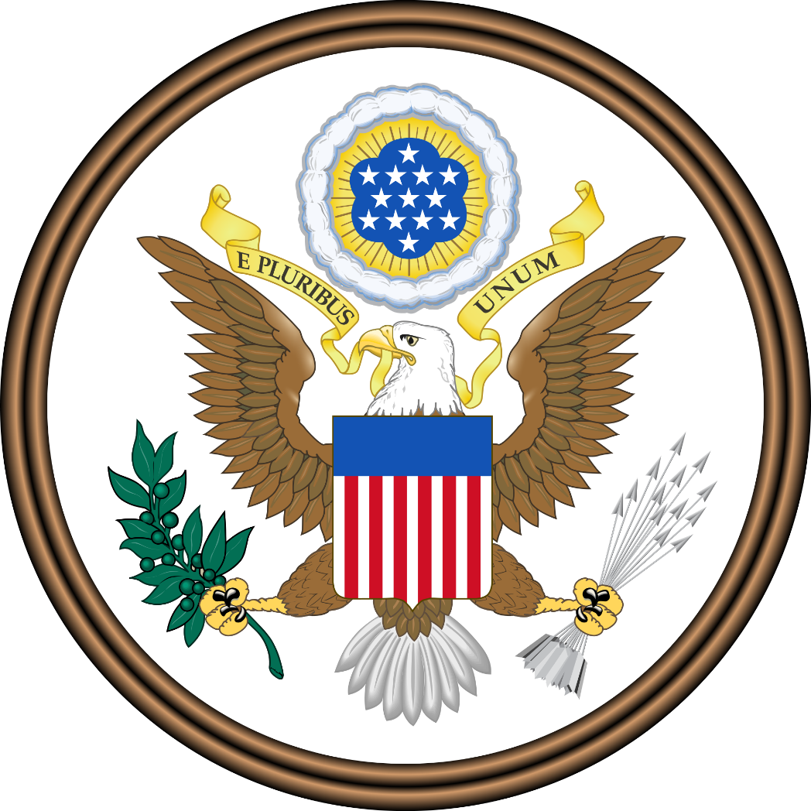

Position Paper
ESMOAS 2017

United States of America
Position Paper for the 2017 ESMOAS Summit of the Americas

I. GENERAL STATEMENT
The United States of America is honored to participate at this year’s Summit of the Americas. As a founding member of the Organization of American States (OAS), the United States hereby reaffirms its commitment to uphold the principles laid in the Charter of the Organization of American States. Under a new administration, the Delegation of the United States expresses a renewed commitment to strengthen the OAS and to cooperate with its member states, particularly in furthering its efforts for regional security, the consolidation of democracy in the western hemisphere, and restructuring the organization’s funding.
Furthermore, the Delegation of the United States, under Donald J. Trump’s presidency, is proud to announce that this year the American people’s interests will be earnestly represented by this delegation. For when President Trump took office, power was handed back to the people. Convinced that a government’s first and foremost duty is with its people, the President promised that under his administration, “every decision on trade, on taxes, on immigration, on foreign affairs, will be made to benefit American workers and American families”, that from that day on “it’s going to be America First” (Trump, 2017).
And ever since, the Trump Administration has made great strides toward the betterment of the American people’s lives: bold actions have been taken –and will continue to be taken– to restore prosperity, keep Americans safe and secure, and hold the government accountable (The White House, 2017).
Along with the actions thus far taken by his Administration, the President’s pro-job, pro-growth agenda is restoring economic optimism and renewing the American spirit. Indeed, the unemployment rate is at its lowest level in over 16 years, while the American consumer sentiment has jumped to a near 14-year high (Ferreira, 2017). And as President Trump recently articulated, “the stock market is at an all-time high”, and “companies are moving back, creating job growth the likes of which the [United States] has not seen in a very long time” (Trump, 2017). However, job creation and economic growth are not President Trump’s priority.
President Trump’s priority is the safety and security of the American people (The White House, Office of the Press Secretary, 2017), which is why the Trump Administration is firmly committed to addressing threats to the United States, including transnational organized crime and illicit trafficking networks as well as the drivers of instability and irregular migration (Tillerson, 2017). Understanding that no member state remains unaffected by these regional security challenges, and that no member state alone can fully address them, the Delegation of the United States expresses its intention and readiness to work with fellow member states in facing these shared threats.
The United States is also committed to promoting and defending representative democracy. President Trump is convinced that “all people deserve a government that cares for their safety, their interests, and their wellbeing”. In light of this conviction, the United States condemns all authoritarian powers that “respect neither their own citizens, nor the sovereign rights of their countries” (Trump, 2017), and encourages “governments in the hemisphere and around the world to take strong action to hold accountable those who undermine democracy, deny human rights, [or] bear responsibility for violence and repression” (U.S. Deparment of State, 2017).
United States of America
Position Paper, Page Two

Accordingly, the United States condemns the Maduro government. Lamenting the actual, outright unacceptable humanitarian and political crisis in Venezuela, the Delegation of the United States reiterates its commitment to work with the OAS and its member states to help the people of Venezuela find a peaceful, democratic, and lasting solution to this crisis. The United States stands by the Venezuelan people as they face the hardships brought about by the Maduro government, and calls once more for a full restoration of democracy and political freedoms in Venezuela.
President Trump also promised that, under his administration, the Government will be accountable to the American people. It is therefore imperative for the Trump Administration to hold itself accountable to the American taxpayer by ensuring effective management and efficient use of resources (Tillerson, 2017). Bearing this in mind, the United States, by adjusting its appropriations, has challenged international and non-governmental organizations to become more efficient and effective, too.
The Delegation of the United States recognizes and applauds the efforts the General Secretariat and OAS member states have made to reform and modernize the organization, striving for its efficiency and effectiveness. Nonetheless, the organization has plenty room for improvement.
The Delegation of the United States is convinced that, in order for the OAS to effectively play its vital role in the western hemisphere, its financial sustainability must be assured; and that, as President Trump stands, no member state should have to bear a disproportionate share of the burden. In light of this, and inspired by the OAS Revitalization and Reform Act of 2013, this delegation urges the OAS and its member states to move toward an assessed quota structure that assures the financial sustainability of the organization as well as fair and equitable quota assessments, so that no member state’s contribution accounts for more than 50 percent of the OAS Regular Fund.
“In fulfilling our obligations to our own nations, we also realize that it’s in everyone’s interest to seek a future where all nations can be sovereign, prosperous, and secure” (Trump, 2017b). Bearing this words in mind, the Delegation of the United States of America looks forward with great anticipation to collaborating and cooperating with the member states’ distinguished delegations in order to achieve the sovereignty, prosperity, and security our nations and our peoples rightfully deserve.

II. PARTICULAR STATEMENTS

A. General Committee (GC)

Topic A: Strengthening and Improving the Reach of the Inter-American Convention against Racism

The United States condemns all forms of racism. In President Trump’s words “No matter the color of our skin or our ethnic heritage, we all live under the same laws, we all salute the same great flag, and we are all made by the same almighty God. We are a Nation founded on the truth that all of us are created equal. As one people, let us move forward to

United States of America
Position Paper, Page Three

rediscover the bonds of love and loyalty that bring us together as Americans” (White House, 2017).
The Delegation of the United States, for this matter, remembers the efforts of Martin Luther King Jr., who fought to end racial segregation and discrimination against African Americans and for their civil rights. The United States is well aware of the problems that accompany racism, which is why this delegation is committed to furthering regional efforts to eradicate racism from the hemisphere.
The United States applauds the efforts the OAS has made to create a safer and fair environment for the Americas peoples, as with the creation of the Inter-American Convention Against Racism. The programs and proposals the OAS has approved for addressing racism have led to open discussion between member states, which certainly brings the hemisphere closer to finding the right path to eradicating this injustice.
Also, this delegation acknowledges with regret the racist disturbances that have occurred this year; this wrongdoing has led to division among the American people. A response of the Trump Administration to this unacceptable behavior was a statement through which those who acted or participated in these racist disturbances were warned about upcoming justice and impelled to correct their behavior (The White House, 2017). In the United States, there is no space for racism nor should there be any in the Americas.
United States urges member states to work together to bring about a brotherhood among the Americas peoples, to cooperate with organizations like the YWCA, which has the purpose of fighting racism against women and raise awareness in the society (Stand Against Racism, n. d.). This delegation holds as a tenet that a government has the obligation of procuring their people’s safety and peace, a government in which they can rely, trust, and work with.
Understanding that it is also the responsibility of the member states to protect the human rights of their peoples, and that the Inter-American Convention Against Racism cannot be fully carried out by individual member states, that cooperation and collaboration between member states is imperative, the Delegation of the United States expresses its firm commitment to work with the member states’ delegations to fulfill said convention and bring the hemisphere closer to an order of peace and justice for all.

Topic B: Achieving More Equitable Inclusion and Participation in the OAS among All States of the Hemisphere

The Delegation of the United States of America cannot ignore the issue that not all the nations that compose the American continent tend to have a strong and healthy democratic government. That is why, on the OAS charter, we fully agreed that “democracy is an indispensable condition for the stability, peace and development of the region” (OAS, 1997).
This been said, the United States expresses its willingness to achieve a more equitable participation in the OAS through different paths, that may or may not suit nations among the hemisphere, but willing to ensure these paths may adapt and work for every nation. Democracy states that whenever a nation accomplish a full democratic act within

United States of America
Position Paper, Page Four

their inhabitants, the healthier democracy, the more effectively it will operate. So, considering this fact.
Currently, under the administration of President Donald Trump, the United States face authority and authoritarian powers that seek to collapse the values, the systems and alliances that prevented conflict and tilted the world towards freedom. It is entirely up to us whether we lift the world to new heights or let it fall into a valley of disrepair. We need to ensure that new generations are raised free from violence and fear. Entire participation of the hemisphere will help shape a better future.
United States is here to reinforce one of the main purposes of the OAS which is: “to promote and consolidate representative democracy, with due respect for the principle of nonintervention” as stated on the OAS Democratic Charter.
We do not expect diverse nations in the hemisphere to share the same cultures and traditions, but we do expect all nations to have the willingness to achieve this main goal, a more equitable participation among all states. Achieving successful development is strongly related in cooperation among nations.
The United Stated does not seek to impose our way of life on anyone, but rather to let it shine as an example for everyone to watch.
We need to build strong nations, to work for our inhabitants, to serve their needs, to ensure their safety and to preserve their rights. We must work and confront together every event that could threat us.

B. Executive Secretariat for Integral Development (SEDI)

TOPIC A: Topic A: Promotion of the Rights of People in Vulnerable Situations

The United States of America recognizes the importance to defend and promote the human rights. Particularly to those who are living in a vulnerable condition due poverty, disabilities, natural disasters or other reasons that creates difficulties to be integrated to society. That is why, United States, acknowledges the importance to participate in this year’s Summit in the Organization of American States to seek solutions on this topic recognizing the historical efforts that this organization has made and contributed to the rest of the world.
With the support of the program that Unites States has compromise with the UN High Commissioner for Human Rights (OHCHR, 1996-2017), the country has been involved in the process of bringing the solutions for our citizens especially for they do not have the lack of leadership, education, enhancing equality and discrimination. Also for combat the impunity and integrate human rights in development and in the economic sphere; widening the democratic space; and early warning the protection of human rights in situations of conflict, violence and insecurity (UN, 2017).
The United States is deeply conscious of the agreement with The United Nations Program of Human Rights Watch (TUSHRW, 2017) which protects and promotes the fundamental rights and dignity of every person subject to the authority of the US government.

United States of America
Position Paper, Page five

Also, the United States, under President Trump´s administration, is focused on helping American citizens in vulnerable situations to make sure they are better off. As President Trump said in the United Nations speech earlier this year: “all responsible leaders have an obligation to serve their own citizens, and the nation-state remains the best vehicle for elevating the human condition” (Trump, 2017) these words can be evidenced in the extraordinary results of the first year in office of President Trump elevating the living conditions of many Americans by bringing back jobs and the opportune reactions during hurricanes Harvey, Irma and Maria that severely affected our country (White House, 2017).
This year, the delegation of United States is committed to contribute with our fellow member states with programs focused on helping them achieve better conditions for their citizens.

TOPIC B: Public policies for improving working and employer’s rights.

America first! Is the creed that characterizes United States policies under President Trump´s administration. The creation of better conditions for our citizens is the main purpose of this administration and has been delivering unprecedent results with the lowest rate of unemployment in 16 years and the returned of great American companies decided to make America great again (Trump, 2017).
United States labor law sets the rights and duties for employees, labor unions, and employers in the US. Its main purpose is to provide an “equality of power” between employers and employees. During the 20th Century, federal labor law created minimum social and economic rights, and encouraged state laws to be on margin to favor employees. (National Labor Relations Act of 1935.) According to United States’ Fair Labor Standards Act of 1938, it is required to pay a federal minimum wage and discourages unhealthy working weeks over 40 hours through time-and-a-half overtime pay. (Fair Labor Standards Act of 1938)
As mentioned before, since President Trump command, job creation rate has gone up meanwhile unemployment rate has been falling. (CNN Money, 2017) The United States economy is closer to full employment; the unemployment rate is 4.3 percent, the lowest rate since January 2001 (NY Times, 2017).
Also, according to Reshoring Initiative, last year, for the first time in decades, more manufacturing jobs came back to the United States than left. The automotive industry has brought the most jobs back to the U.S., followed by makers of electronic components and appliances. According to the report made by Reshoring Initiative, the industries mentioned before are “focused on products whose size and weight suggest offshoring never offered great total cost savings.” (USA Today, 2017).
The delegation of United States is motivated to cooperate in this year’s summit of the OAS and help, with the great example of our countries’ newest policies and fabulous results, shape the hemisphere and make the Americas great again.

United States of America
Position Paper, Page Six

C. Secretariat for Multidimensional Security (SMS)

Topic A: New Programs to Help Combat or Prevent Transnational Organized Crime

The Delegation of the United States of America claims that to protect the wellbeing of its citizens, as well as that of its fellow member states, it is its obligation to create new programs to help combat and prevent transnational organized crime. This is a top priority for the delegation and requires a comprehensive and decisive approach to dismantle these organized crime syndicates and restore safety for the American people.
In addition to the Narcotics Rewards Program, which was established by Congress in 1986, the U.S. Congress has established the Transnational Organized Crime Rewards Program in 2013 as a tool to assist the U.S. Government to identify and bring to justice members of significant transnational criminal organizations (U.S. Department of State, n.d.-a).
In order to further enhance the combat and prevention of transnational criminal organizations and subsidiary organizations, the Delegation of the United States of America is searching for cooperation with American counterparts, including, where appropriate and permitted by law, through sharing of intelligence and law enforcement information and through increased security sector assistance to foreign partners by the Attorney General and the Secretary of Homeland Security (The White House, 2017-a).
Border security is critically important to the national security of the United States. Aliens who illegally enter the United States without inspection or admission present a significant threat to national security and public safety as they have not been identified or inspected by Federal immigration officers to determine their admissibility to the United States. The recent surge of illegal immigration at the southern border with Mexico has placed a significant strain on Federal resources and overwhelmed agencies charged with border security and immigration enforcement, as well as the local communities into which many of the aliens are placed. Transnational criminal organizations operate sophisticated drug- and human-trafficking networks and smuggling operations on both sides of the southern border, contributing to a vast increase in violent crime and deaths from dangerous drugs. Among those who illegally enter are those who seek to harm Americans through acts of terror or criminal conduct. Continued illegal immigration presents a clear and present danger to the interests of the United States (White House, 2017-b).
Hence, the United States of America does not only search for cooperation with other countries to develop new programs to help combat or prevent transnational organized crime, but does also consider it its obligation to enhance the protection of its own borders in order to keep illegal immigrants – who are an imminent danger to the country’s national security – out of the United States of America.

United States of America
Position Paper, Page Seven

Topic B: Strengthening and Increasing Hemispheric Agreements on Disarmament and Non-Proliferation

The Delegation of the United States of America is devoted to strengthening and increasing hemispheric agreements on disarmament and non-proliferation. The delegation considers it its highest priority to fight this threat through bilateral and multilateral treaties. By signing the Arms Trade Treaty in 2013 which regulates the international trade in conventional arms the delegation took a step towards achieving this goal. With this the Delegation of the United States of America strives for the non-proliferation of Weapons of Mass Destruction (WMD) such as nuclear, chemical or biological weapons and all related materials, technologies, and expertise (U.S. Department of State, n.d.–b).
Furthermore, it is the duty of the Delegation of the United States of America to prevent terrorists from acquiring those weapons. Nevertheless, the United States consider it important to respect the national sovereignty and security of each country which is why the United States won’t sign the Treaty on Prohibition of Nuclear Weapons. For over 70 years mutual assured destruction helped to keep peace all over the world and protected us from nuclear attacks on our hemisphere. For this reason, the United States claim that it is neither necessary nor safe to destroy all nuclear weapons. Instead the delegation believes in increasing hemispheric agreements on this topic as well as more control concerning its compliance and severe sanctions for proliferation actions or the construction of new nuclear weapons without control (CBC, 2017). For this reason, the United States cannot accept deals such as the Iran Nuclear Deal, which is just postponing the building of a nuclear weapon by Iran and not preventing it (Deutsche Welle, 2017).
The United States is convinced that there must be strict rules throughout the whole continent concerning disarmament, nonproliferation and the building of mass destruction weapons to ensure and keep peace on our hemisphere while on the other side respecting the sovereignty of each country.

D. Secretariat for Strengthening Democracy (SSD)

Topic A: Strengthening and Modernizing Management Mechanisms at the Municipal Level
The delegation of United States, as strongly democratic country and leader in the quality of internal institutions and democratic practices, applauds the inclusion of this topic to this year´s summit and reinforces the willingness to provide our example of success to other member states.
The efforts towards the management mechanisms at the municipal level that the OAS has will improve the quality of life of people in municipalities that are not heard or suffer from high indexes of corruption.
Our nation has one of the most sophisticated systems that provides with a voice to every corner of the United States and ensures the effectiveness of our institutions. With the 12th place in the E-Government Development Index from United Nations in 2016 we were the best positioned country of the hemisphere (UN, 2016).

United States of America
Position Paper, Page Eight

The delegation of United States is convinced that the more democratic and integrated a country gets, the more they succeed and we will continue to contribute to the world as an example of this hypothesis.
Topic B: New Programs for the Inter-American Program on Education for Democratic Values and Practices

United States in hand with OAS, has always been compromised to reinforce values, especially democratic ones, that are the core of the greatness of our organization and that ensures the freedom of our hemisphere. As a fully democratic country and as a clear example in our continent, United States would like to continue sharing experiences and achievements, not imposing them on anyone but letting them shine, with our fellow member states to help them achieve fully democratic values and practices in the near future.
The delegation of United States of America stands with programs to encourage democracy and education investing around $15.7 million (IAF; Smart, Cost-effective Development Approach) for out self- projects according to Inter-American Foundation(IAF) in 2015, making all of these success; Higher education serves as a network of supporting Inter-American based on solidarity and mutual assistance.
The U.S. Department of Education is interested in reinforcing cultural background in the hemisphere, implementing activities in which everyone can get into a real world and have a better performance in which nowadays is Bilingual. In addition, recognizing democracy as an obligation to promote it and defend it every day, interlaced with constitutional rights, abolition of poverty and economic growth in America.
U.S Administrations Government Plan for 2018, IAF and other Foundations programs would be cease of the Budget USA provides. Our purpose eradicating these programs is to support Local and National projects. To shut down the program, an estimated of $4.6 million of the Budget (United States of America. Congressional budget justification 2018) is required, this includes: payments and salaries for personnel during the shutdown.
However, it is relevant for the U.S. to keep the structure of the IAF program passing the essence to American countries and guide them in implementing a New Editions. United states in hand with Chile and Colombia has been participating in researches within the purpose of comparing ways of understanding the role of Education, Democracy and Values in different American Countries. The results of this research were in base of students between 14-17 years old through educational programs and tests schools. Until now, United States in hand with IAF is active in American countries like: Argentina, Chile, Jamaica, Bolivia and others.
As a nation that keep the goal of making the world a better place, we stand up for sharing our knowledge and getting into forgotten places, in hand with our values: Liberty, Equality and Justice. Keeping the same spirit of researches, countries involved and compromise their citizens, is our mission to have the opportunity of expanding the Newest IAF Edition giving the opportunity and responsibility to other fellow states to reaffirm their compromise in sharing democratic values among their citizens.

United States of America
Position Paper, Page Nine

III. References
The White House. (n.d.). Retrieved October 25, 2017, from https://www.whitehouse.gov/

United Nations, it's your world. (n.d.). Retrieved October 25, 2017, from http://www.un.org/

CBC (2017). 122 countries adopt ‘historic’ UN treaty to ban nuclear weapons.
http://www.cbc.ca/news/world/un-treaty-ban-nuclear-weapons-1.4192761

Deutsche Welle (2017). What are Donald Trump’s objections to the Iran Nuclear Deal?. Retrieved from http://www.dw.com/en/what-are-donald-trumps-objections-to-the-iran-nuclear-deal/a-40601669

U. S. Department of State (n.d.-b). Key Engagements. Retrieved from https://www.state.gov/t/isn/

Trump, D. J. (2017a). The Inaugural Address [Transcript]. Retrieved from https://www.whitehouse.gov/inaugural-address

The White House. (2017). President Trump’s First 100 Days. Retrieved from https://www.whitehouse.gov/100-days

Ferreira, J. (October 6, 2017a). US Employment Rate Lowest in Over 16 Years. Trading Economics. Retrieved from https://tradingeconomics.com/united-states/unemployment-rate
Ferreira, J. (October 13, 2017b). US Consumer Sentiment Jumps to Near 14-Year High. Trading Economics. Retrieved from https://tradingeconomics.com/united-states/consumer-confidence

Trump, D. J. (2017b). Remarks by President Trump to the 72nd Session of the United Nations General Assembly [Transcript]. Retrieved from https://www.whitehouse.gov/the-press-office/2017/09/19/remarks-president-trump-72nd-session-united-nations-general-assembly

The White House, Office of the Press Secretary. (2017). President Donald J. Trump’s First Month: Achieving Results for the American People [Press release]. Retrieved from https://www.whitehouse.gov/the-press-office/2017/02/20/president-donald-j-trumps-first-month-achieving-results-american-people

United States of America
Position Paper, Page Ten

U.S. Department of State. (2017). Defending Democracy in Venezuela [Press release]. Retrieved from https://www.state.gov/r/pa/prs/ps/2017/07/272940.htm

Tillerson, R. W. (2017). FY 2018 Congressional Budget Justification - Secretary's Letter [PDF file]. Retrieved from https://www.state.gov/documents/organization/271282.pdf

Organization of American States Revitalization and Reform Act of 2013, P. L. No. 113-41. Retrieved from https://www.congress.gov/bill/113th-congress/senate-bill/793/text

U. S. Department of State (n.d.-a). Transnational Organized Crime Rewards Program. Retrieved from https://www.state.gov/j/inl/tocrewards/

White House (2017-b). Presidential Executive Order on Enforcing Federal Law with Respect to Transnational Criminal Organizations and Preventing International Trafficking. Retrieved from https://www.whitehouse.gov/the-press-office/2017/02/09/presidential-executive-order-enforcing-federal-law-respect-transnational
White House (2017-a). Executive Order: Border Security and Immigration Enforcement Improvements. Retrieved from https://www.whitehouse.gov/the-press-office/2017/01/25/executive-order-border-security-and-immigration-enforcement-improvements
Charter of the Organization of American States (A-41). Retrieved October 05,2017, from. http://www.oas.org/en/sla/dil/inter_american_treaties_A-41_charter_OAS.asp
Inter-American Democratic Charter. (2001, September 11) Retrieved October 05, 2017, from http://www.oas.org/OASpage/eng/Documents/Democractic_Charter.htm
1938, F. L. (n.d.).
CNN. (2017). Retrieved from http://money.cnn.com/2017/08/04/news/economy/july-jobs-report/index.html
National Labor Relations Act of 1935. (n.d.).
NEWSEXAMINER. (2017). Retrieved from http://www.newsexaminer.com/opinion/how-fast-can-our-economy-grow-at-full-employment/article_13b5491e-f004-52eb-ac68-56084468ade5.html
NLRB. (1935). Retrieved from https://www.nlrb.gov/resources/national-labor-relations-act
NYTIMES. (2017). Retrieved from https://www.nytimes.com/2017/09/05/upshot/under-trump-job-market-has-improved-more-for-clinton-supporters.html

United States of America
Position Paper, Page Eleven

OHCHR. (1996-2017). Retrieved from UNITED NATIONS HUMAN RIGHTS: http://www.ohchr.org/EN/AboutUs/Pages/WhoWeAre.aspx
RECODE. (2017). Retrieved from https://www.recode.net/2017/5/26/15656120/manufacturing-jobs-automation-ai-us-increase-robot-sales-reshoring-offshoring
TODAY, U. (2017). Retrieved from https://www.usatoday.com/story/money/business/2016/04/23/24-7-wallst-economy-manufacturers-jobs-outsourcing/83406518/
TUSHRW Berry, D. (2017). The United States Human Rights Watch. Retrieved from https://www.hrw.org/united-states
UNITED NATION HUMAN RIGHTS. (2017). Retrieved from http://www.ohchr.org/EN/AboutUs/Pages/WhoWeAre.aspx

